**Managing microservices and APIs with Kong and Konga**

**Step 1** :- Start using Konga dashboard in your browser with your machine IP. By default konga dashboard running on 1337 port.

**Dashboard**

The dashboard displays basic information about the Kong instance you’re currently connected, the underlying database and the available plugins.

More detailed information can be found in the INFO page.

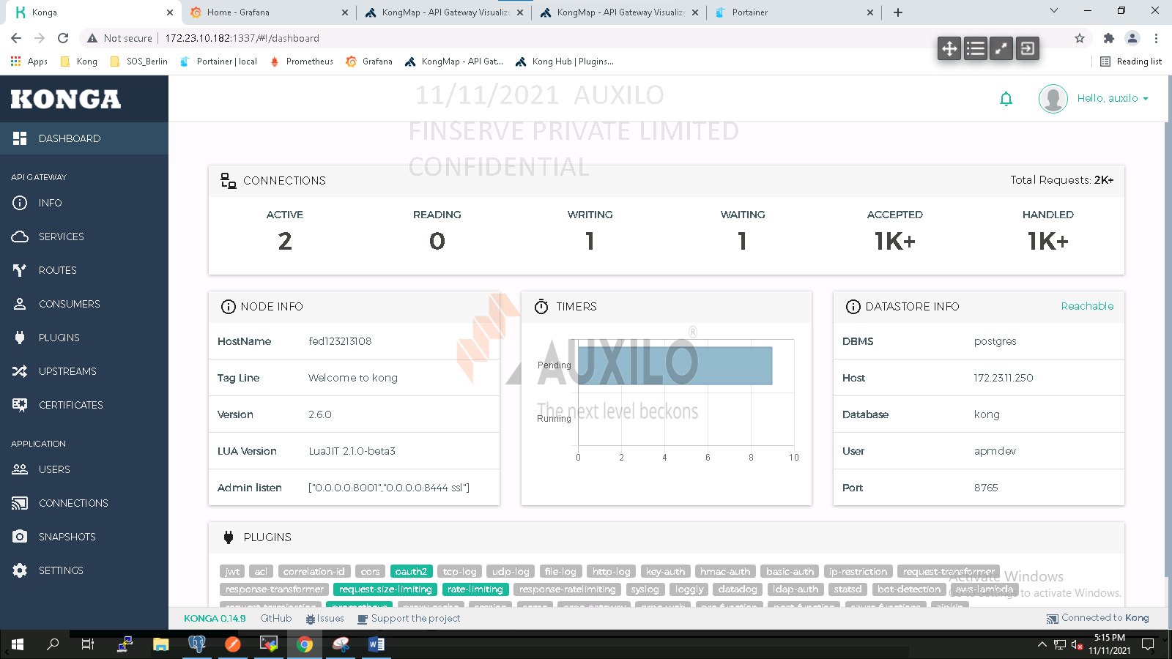

**Node Info**

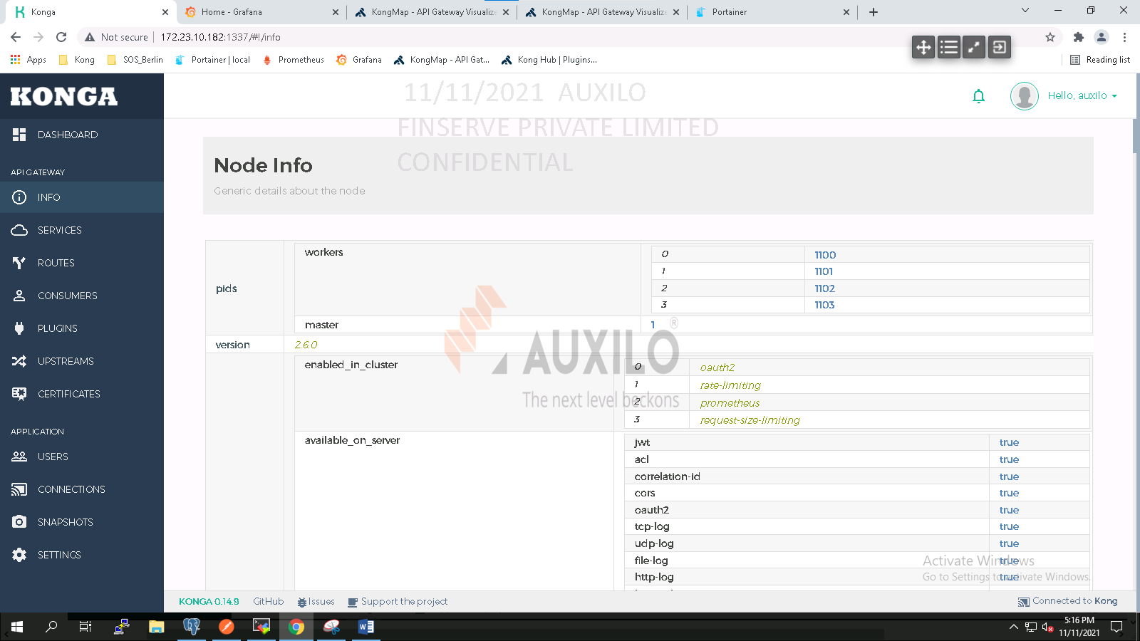

**Step 2**:- Creating Services and Routes

Navigate to service page.

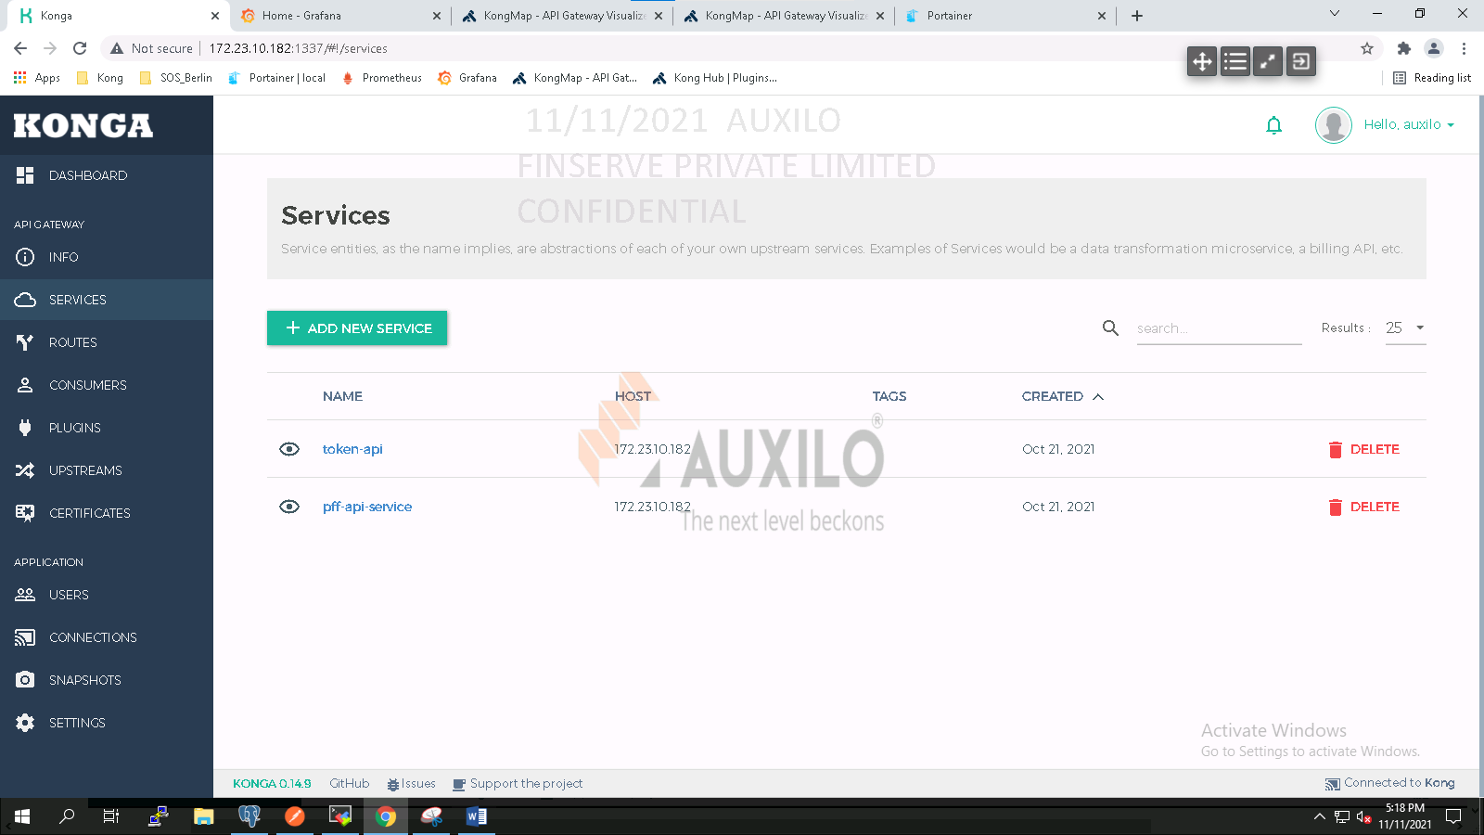

Navigate to the services page and add a **pff-api-service** . Fill in the form as follows:

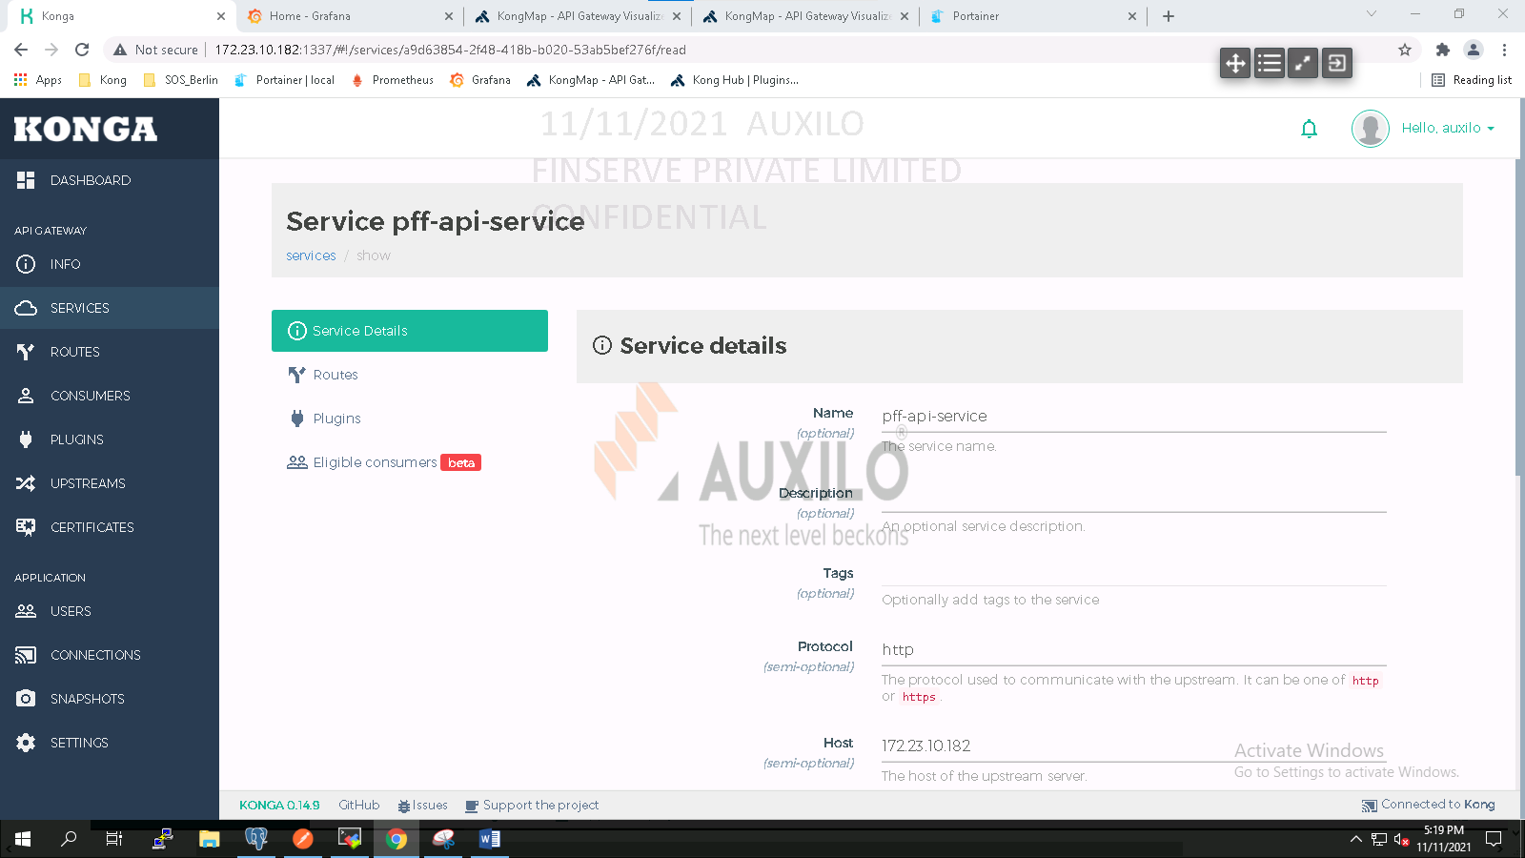

We need to create routes to those resources.

Click on the **pff-api-service**, select the routes tab and add a new route.

Fill in the form as follows and hit submit:

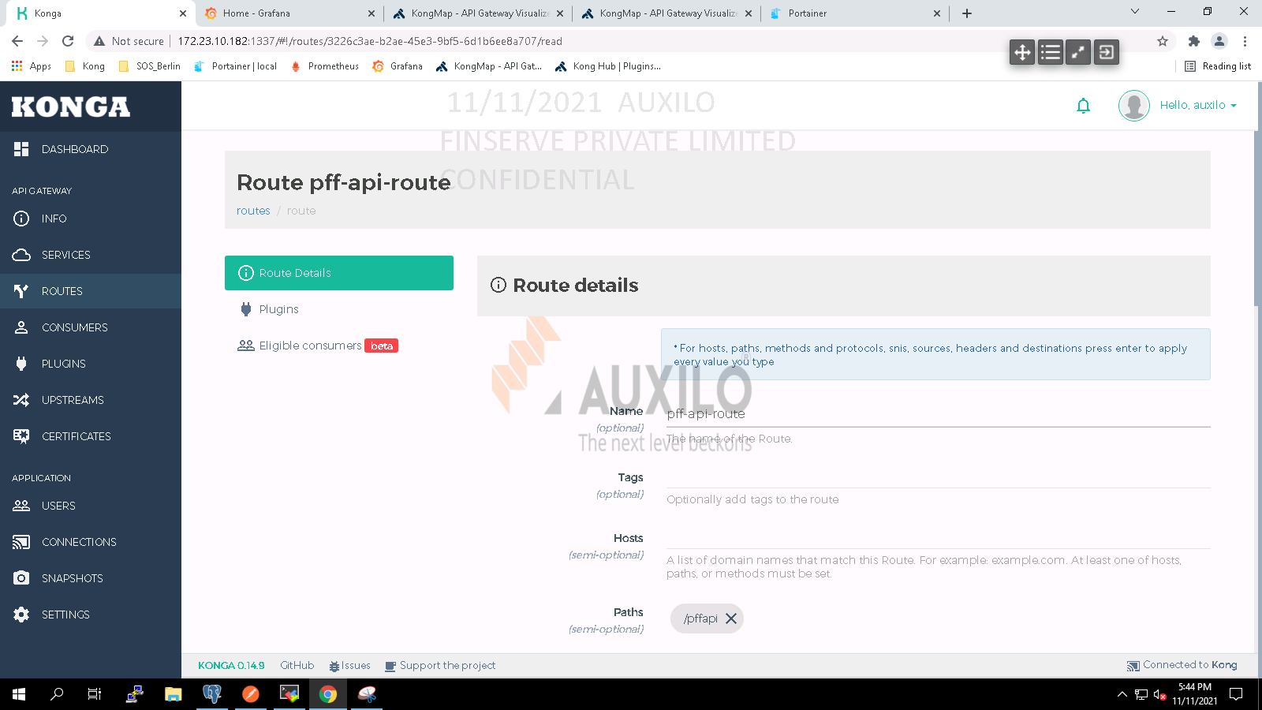

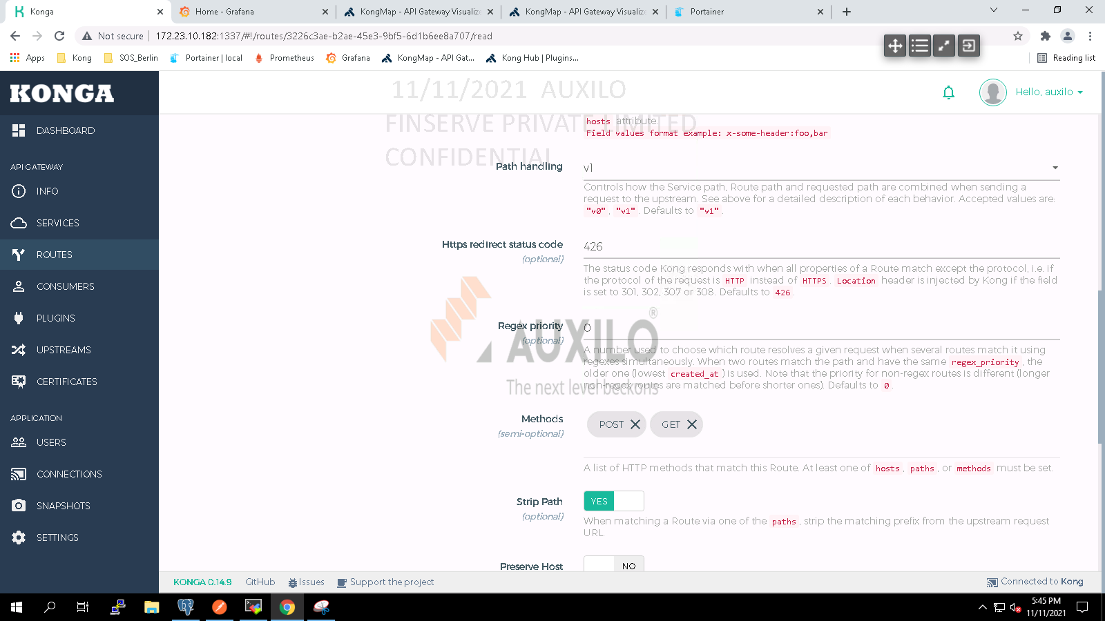

We’ve successfully deployed Kong & Konga and managed to access the**pff-api-service**  API through our gateway.

**Step 3**:- Securing resources

Kong provides a number of ways to do that by using Authentication and security plugins. To keep things simple, we’re going to use the Oauth2 plugin on our service.

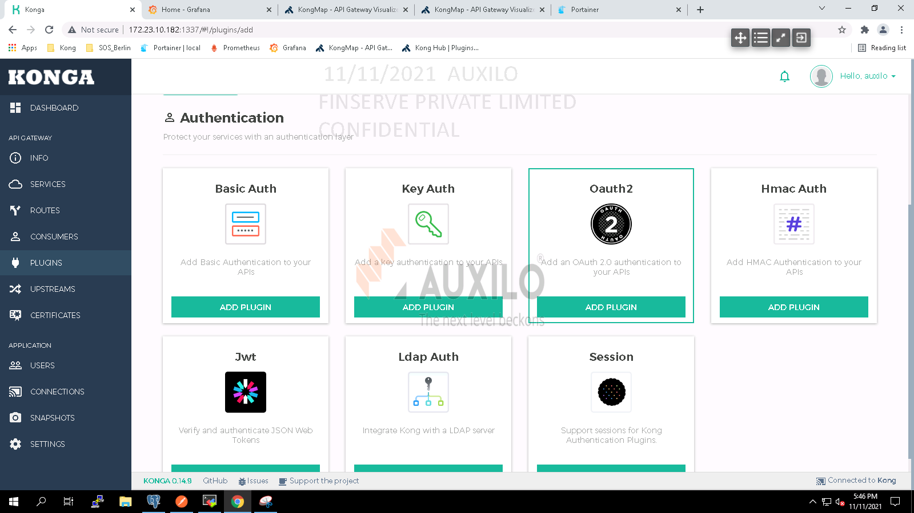

Navigate to the plugins tab, hit the add plugin button and select the Oauth2 plugin.

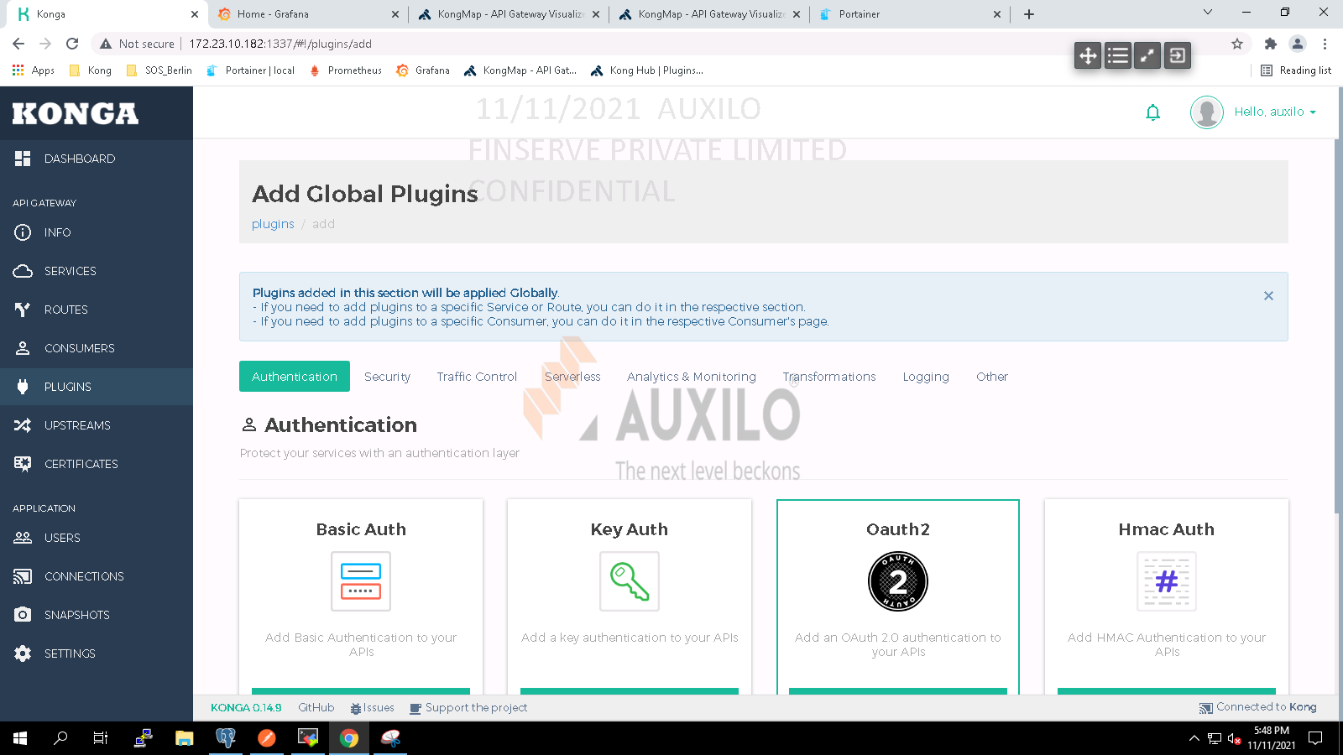

Select options as per below snapshot.

Provision key: provisionkey

Enable password grant

Enable global credentials

auth header name: authorization

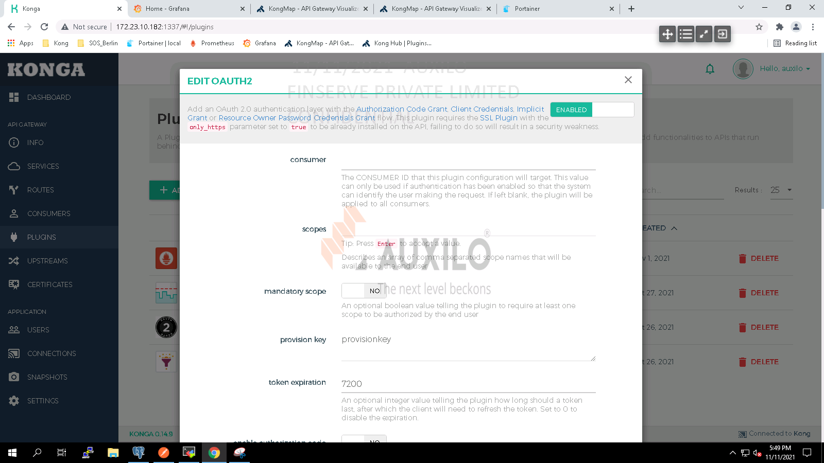

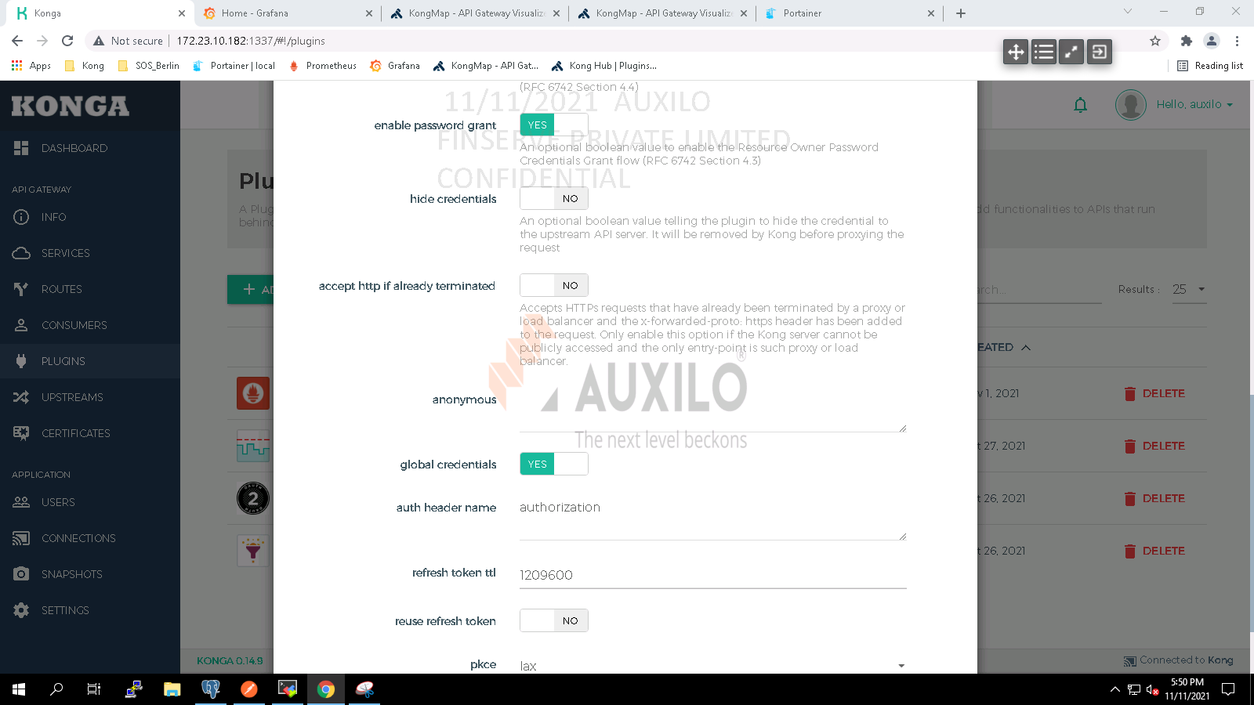

**Step 4**:- Creating consumer to access APIs.

Navigate to consumers page

